Final project

Ziyan Wang

06083050

OVERVIEW:

Build a network to simulate the airports connections (route map), let user to quick check how to fly from one airport to another then show the result, interactively (embed it into Flask framework).

1. GET DATA FROM [https://raw.githubusercontent.com/jpatokal/openflights/master/data/routes.dat](https://raw.githubusercontent.com/jpatokal/openflights/master/data/airports.dat)

This screen shot tell details about the data we will use.

(actually used is Destination airport and Source airport) BOTH ARE IATA

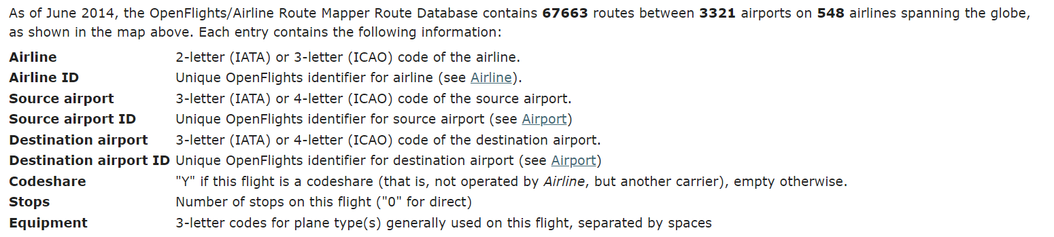

1. GET AIRPORTS DATA FROM <https://raw.githubusercontent.com/jpatokal/openflights/master/data/airports.dat:>

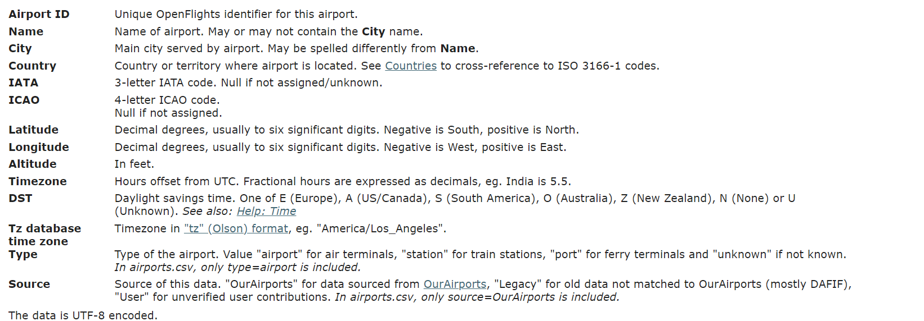

Then build a airports-percise location database use the Airport (IATA) AND Latitude, Longitude data

1. THEN GENERATE A CSV FILE, called routes.csv , so in the future no need to request data again.
2. BUILD A GRAPH, using the routes.csv file.
3. BUILD A FLASK framework then let user
   1. User can chose an airport to see all connected one.
   2. Can show the connection graphically. ( this may be hard hope to do this)
   3. check the source -> destination as they wish
   4. Show those routes using graph (as a route map).( this may be hard hope to do this)
4. Result will shown both in words (as a list, air) and graphically ( this may be hard hope to do this)in the